**Hands on Project for William Lawler**

January 22, 2018

1. Create an interface program in C/C++ for an off the shelf 24-bit ADC board from General Standards.

2. IEM will supply the details of the 24-bit ADC card ahead of time. The card details are below.

3. The interface should perform the following tasks:

a. Accept inputs from one of the digital inputs on the card or just user keyboard to start and stop the acquisition process

b. Setup the board capture parameters, e.g. maximum capture speed (200KHz)

c. Capture input waveform attached to analog channel 1

d. Store the waveform to a MATLAB readable file

e. Analyze the waveform to establish that capture was done correctly

**Card Manufacturer**

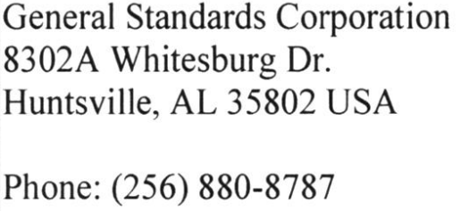

[**http://www.generalstandards.com/view-products2.php?BD_family=24dsi6ln**](http://www.generalstandards.com/view-products2.php?BD_family=24dsi6ln)

**24-bit ADC Card**

